|  |
| --- |
| Department of Software Engineering  Mehran University of Engineering and Technology, Jamshoro |

|  |  |  |  |
| --- | --- | --- | --- |
| Course: SWE324 - Data Warehousing and Data Mining | | | |
| Instructor | Rabeea Jaffari | **Practical/Lab No.** | 03 |
| Date | 16 April 2019 | **CLOs** | CLO-4: P3 & P4 |
| Signature |  | **Assessment Score** | 1 Mark |

|  |  |
| --- | --- |
| Topic | To familiar with OLTP system query execution |
| Objectives | * To learn query execution in OLTP databases |

|  |
| --- |
| Lab Discussion: Theoretical concepts and Procedural steps |

**OLTP QUERY EXECUTION:** Since OLTP are operational databases that record daily transactional activities, the typical queries in an OLTP system comprise of retrievals, insertions, updates and deletions. The preferred query language to perform these mentioned tasks is Structured Query Language (SQL).

To get started with SQL, we need to have any SQL Package installed such as MYSQL, SQLSERVER or ORACLE EXPRESS etc.

**SQLSUBLANGUAGES:**

SQL works on the following basic database structures in the databases:

1. Tables
2. Views
3. Indexes
4. Sequences
5. Synonyms

SQL is usually divided into following sub languages to perform operations on the database structures above:

**DDL:** Data definition language handles the definition (which includes creation, modification and deletion) of basic database structures mentioned above). Includes CREATE, ALTER and DROP SQL commands.

**DML:** Data manipulation language handles the data within the database structures and includes SQL commands such as INSERT, UPDATE and DELETE.

**TCL:** Transaction control language involves the commands which manage changes to the database made by the transactions (DML commands). It involves SQL commands such COMMIT for making a transaction permanent or ROLLBACK to undo a DML operation.

**DRL:** Data retrieval language is used to retrieve data from the databases. It involves SELECT SQL command.

**IMPORTANT SQL COMMANDS:**Some of the most important SQL commands include:

1. **SELECT** - extracts data from a database
2. **UPDATE** - updates data in a database
3. **DELETE** - deletes data from a database
4. **INSERT INTO** - inserts new data into a database
5. **CREATE DATABASE** - creates a new database
6. **ALTER DATABASE** - modifies a database
7. **CREATE TABLE** - creates a new table
8. **ALTER TABLE** - modifies a table
9. **DROP TABLE** - deletes a table
10. **CREATE INDEX** - creates an index (search key)
11. **DROP INDEX** - deletes an index

BASIC SQL COMMANDS SYNTAX:

|  |  |
| --- | --- |
| **SQL Statement** | **Syntax** |
| AND / OR | SELECT column_name(s) FROM table_name WHERE condition AND|OR condition |
| ALTER TABLE | ALTER TABLE table_name  ADD column_namedatatype  or  ALTER TABLE table_name  DROP COLUMN column_name |
| AS (alias) | SELECT column_name AS column_alias FROM table_name  or  SELECT column_name FROM table_name  AS table_alias |
| BETWEEN | SELECT column_name(s) FROM table_name WHERE column_name BETWEEN value1 AND value2 |
| CREATE DATABASE | CREATE DATABASE database_name |
| CREATE TABLE | CREATE TABLE table_name ( column_name1 data_type, column_name2 data_type, column_name3 data_type, ... ) |
| CREATE INDEX | CREATE INDEX index_name ON table_name (column_name)  or  CREATE UNIQUE INDEX index_name ON table_name (column_name) |
| CREATE VIEW | CREATE VIEW view_name AS SELECT column_name(s) FROM table_name WHERE condition |
| DELETE | DELETE FROM table_name WHERE some_column=some_value  or  DELETE FROM table_name  (**Note:**Deletes the entire table!!)  DELETE * FROM table_name  (**Note:**Deletes the entire table!!) |
| DROP DATABASE | DROP DATABASE database_name |
| DROP INDEX | DROP INDEX table_name.index_name (SQL Server) DROP INDEX index_name ON table_name (MS Access) DROP INDEX index_name (DB2/Oracle) ALTER TABLE table_name DROP INDEX index_name (MySQL) |
| DROP TABLE | DROP TABLE table_name |
| EXISTS | IF EXISTS (SELECT * FROM table_name WHERE id = ?) BEGIN --do what needs to be done if exists END ELSE BEGIN --do what needs to be done if not END |
| GROUP BY | SELECT column_name, aggregate_function(column_name) FROM table_name WHERE column_name operator value GROUP BY column_name |
| HAVING | SELECT column_name, aggregate_function(column_name) FROM table_name WHERE column_name operator value GROUP BY column_name HAVING aggregate_function(column_name) operator value |
| IN | SELECT column_name(s) FROM table_name WHERE column_name IN (value1,value2,..) |
| INSERT INTO | INSERT INTO table_name VALUES (value1, value2, value3,....)  *or*  INSERT INTO table_name (column1, column2, column3,...) VALUES (value1, value2, value3,....) |
| INNER JOIN | SELECT column_name(s) FROM table_name1 INNER JOIN table_name2  ON table_name1.column_name=table_name2.column_name |
| LEFT JOIN | SELECT column_name(s) FROM table_name1 LEFT JOIN table_name2  ON table_name1.column_name=table_name2.column_name |
| RIGHT JOIN | SELECT column_name(s) FROM table_name1 RIGHT JOIN table_name2  ON table_name1.column_name=table_name2.column_name |
| FULL JOIN | SELECT column_name(s) FROM table_name1 FULL JOIN table_name2  ON table_name1.column_name=table_name2.column_name |
| LIKE | SELECT column_name(s) FROM table_name WHERE column_name LIKE pattern |
| ORDER BY | SELECT column_name(s) FROM table_name ORDER BY column_name [ASC|DESC] |
| SELECT | SELECT column_name(s) FROM table_name |
| SELECT * | SELECT * FROM table_name |
| SELECT DISTINCT | SELECT DISTINCT column_name(s) FROM table_name |
| SELECT INTO | SELECT * INTO new_table_name [IN externaldatabase] FROM old_table_name  *or*  SELECT column_name(s) INTO new_table_name [IN externaldatabase] FROM old_table_name |
| SELECT TOP | SELECT TOP number|percentcolumn_name(s) FROM table_name |
| TRUNCATE TABLE | TRUNCATE TABLE table_name |
| UNION | SELECT column_name(s) FROM table_name1 UNION SELECT column_name(s) FROM table_name2 |
| UNION ALL | SELECT column_name(s) FROM table_name1 UNION ALL SELECT column_name(s) FROM table_name2 |
| UPDATE | UPDATE table_name SET column1=value, column2=value,... WHERE some_column=some_value |
| WHERE | SELECT column_name(s) FROM table_name WHERE column_name operator value |

It should be noted that OLTP systems are not suitable for analytical processing or making decisions therefore business queries are usually difficult to execute using OLTP systems and involve the use of complex joins.

**PRACTICING SQL SKILL:**

Prepare Sample Data To Practice SQL Skill.

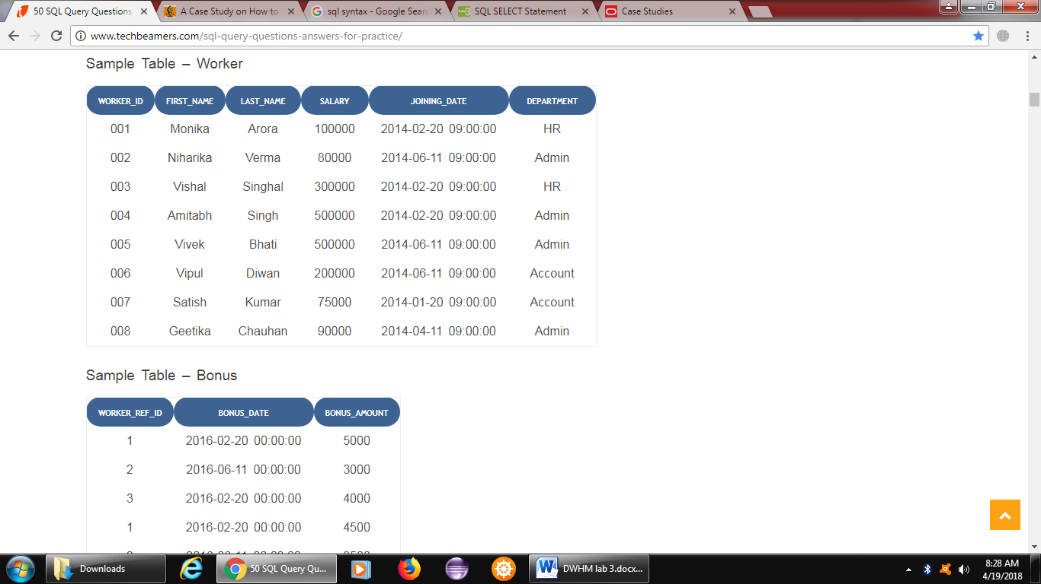

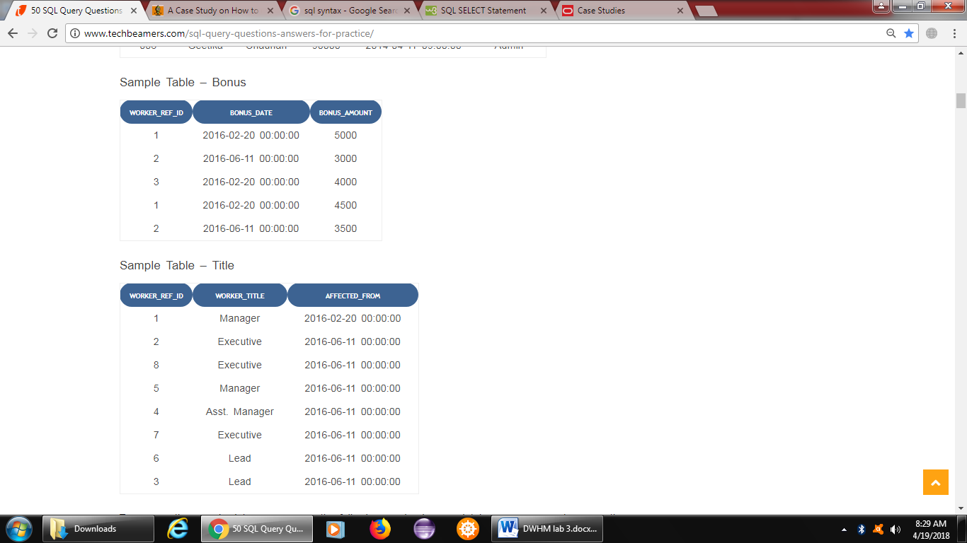

**Sample data can be created using the following sql script:**

CREATE DATABASE ORG;

SHOW DATABASES;

USE ORG;

CREATE TABLE Worker(

WORKER_ID INT NOT NULL PRIMARY KEY AUTO_INCREMENT,

FIRST_NAME CHAR(25),

LAST_NAME CHAR(25),

SALARY INT(15),

JOINING_DATE DATETIME,

DEPARTMENT CHAR(25)

);

INSERT INTO Worker

(WORKER_ID, FIRST_NAME, LAST_NAME, SALARY, JOINING_DATE, DEPARTMENT) VALUES

(001,'Monika','Arora',100000,'14-02-20 09.00.00','HR'),

(002,'Niharika','Verma',80000,'14-06-11 09.00.00','Admin'),

(003,'Vishal','Singhal',300000,'14-02-20 09.00.00','HR'),

(004,'Amitabh','Singh',500000,'14-02-20 09.00.00','Admin'),

(005,'Vivek','Bhati',500000,'14-06-11 09.00.00','Admin'),

(006,'Vipul','Diwan',200000,'14-06-11 09.00.00','Account'),

(007,'Satish','Kumar',75000,'14-01-20 09.00.00','Account'),

(008,'Geetika','Chauhan',90000,'14-04-11 09.00.00','Admin');

CREATE TABLE Bonus(

WORKER_REF_ID INT,

BONUS_AMOUNT INT(10),

BONUS_DATE DATETIME,

FOREIGN KEY (WORKER_REF_ID)

REFERENCES Worker(WORKER_ID)

ON DELETE CASCADE

);

INSERT INTO Bonus

(WORKER_REF_ID, BONUS_AMOUNT, BONUS_DATE) VALUES

(001,5000,'16-02-20'),

(002,3000,'16-06-11'),

(003,4000,'16-02-20'),

(001,4500,'16-02-20'),

(002,3500,'16-06-11');

CREATE TABLE Title(

WORKER_REF_ID INT,

WORKER_TITLE CHAR(25),

AFFECTED_FROM DATETIME,

FOREIGN KEY (WORKER_REF_ID)

REFERENCES Worker(WORKER_ID)

ON DELETE CASCADE

);

INSERT INTO Title

(WORKER_REF_ID, WORKER_TITLE, AFFECTED_FROM) VALUES

(001,'Manager','2016-02-20 00:00:00'),

(002,'Executive','2016-06-11 00:00:00'),

(008,'Executive','2016-06-11 00:00:00'),

(005,'Manager','2016-06-11 00:00:00'),

(004,'Asst. Manager','2016-06-11 00:00:00'),

(007,'Executive','2016-06-11 00:00:00'),

(006,'Lead','2016-06-11 00:00:00'),

(003,'Lead','2016-06-11 00:00:00');

**SQL QUERIES:**

1. Write An SQL Query To Fetch “FIRST_NAME” From Worker Table Using The Alias Name As <WORKER_NAME>.

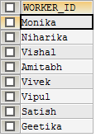

1. Write An SQL Query To Fetch “FIRST_NAME” From Worker Table In Upper Case.

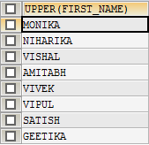

1. Write An SQL Query To Fetch Unique Values Of DEPARTMENT From Worker Table.

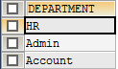

1. Write An SQL Query To Print Last Three Characters Of  FIRST_NAME From Worker Table.

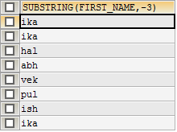

1. Write An SQL Query To Print The FIRST_NAME From Worker Table After Removing White Spaces From The Left Side.

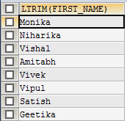

1. Write An SQL Query To Print The FIRST_NAME From Worker Table After Replacing ‘a’ With ‘A’.

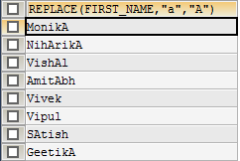

1. Write An SQL Query To Print All Worker Details From The Worker Table Order By FIRST_NAME Descending.

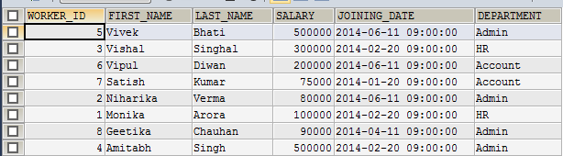

1. Write An SQL Query To Print Details For Workers With The First Name As “Vipul” And “Satish” From Worker Table.

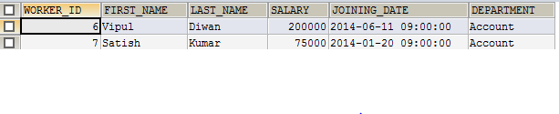

1. Write An SQL Query To Print Details Of Workers With DEPARTMENT Name As “Admin”.

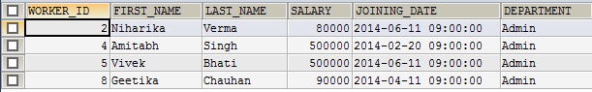

1. Write An SQL Query To Print Details Of The Workers Whose SALARY Lies Between 100000 And 500000.

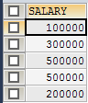

1. Write An SQL Query To Print Details Of The Workers Who Have Joined In Jan’2014.



1. Write An SQL Query To Fetch The Count Of Employees Working In The Department ‘Admin’.



1. Write An SQL Query To Fetch The No. Of Workers For Each Department In The Ascending Order.

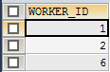

1. Write An SQL Query To Fetch The List Of Employees With The Same Salary.



1. Write An SQL Query To Show The Second Highest Salary From A Table.



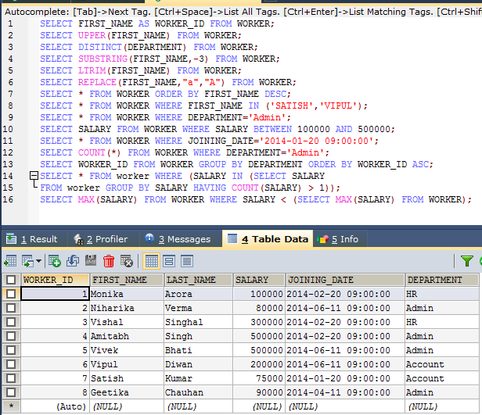

|  |
| --- |
| Lab Tasks |
| Submission Date: 26-04-18 |

Execute OLTP queries for the following scenario:

*An organization has a main data table that lists events. Each event has a series of fields including duration, reason code and status.*

*The OLTP system has a table of statuses with attributes status code and Name and there is a common field between the main table (status code), which allows the organization to print the status name rather than the code.*

*There are four statuses (ready, delay, spare and down) and there are a range of reasons associated with each status with reason codes. It is possible for the same reason code to exist in two statuses (e.g. delay maintenance and down maintenance).*

*For some reason, the source database has four tables of reasons (one for each status). Each of these has a field which links to the main reason code.*

*The organization wishes to do the following:*

*When the main table record status is ‘delay’, then retrieve the name in the ‘delay’ table which corresponds to the main table delay code. When the status is ‘down’, do the same thing but look up the name in the ‘down’ table.*

**Sample screenshots:**

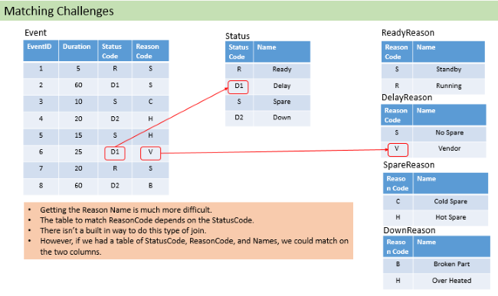

Query output should be:

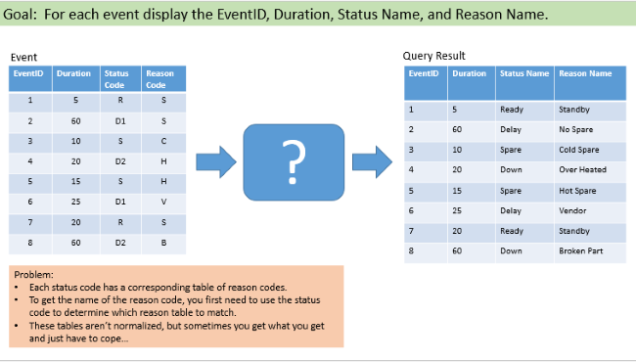

**Hint: Look regarding joins and union in sql.**

* event

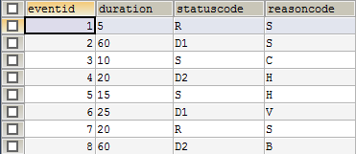

* status

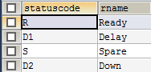

* ready



* delay



* spare



* down



SELECT eventid, duration, s.rname AS statusname, r.rname AS reasonname FROM EVENT e JOIN STATUS s ON e.statuscode=s.statuscode

JOIN(SELECT 'R' AS statuscode, 'ready' AS statusname, reasoncode, rname FROM ready UNION SELECT 'D' AS statuscode, 'delay' AS

statusname, reasoncode, rname FROM delay UNION SELECT'S' AS statuscode, 'spare' AS statusname, reasoncode, rname FROM spare UNION

SELECT 'D1' AS statuscode, 'down' AS statusname, reasoncode, rname FROM down)AS r ON e.statuscode=s.statuscode AND

e.reasoncode=r.reasoncode;



